Appointment Brief

Functional Skills/
Employability Tutor

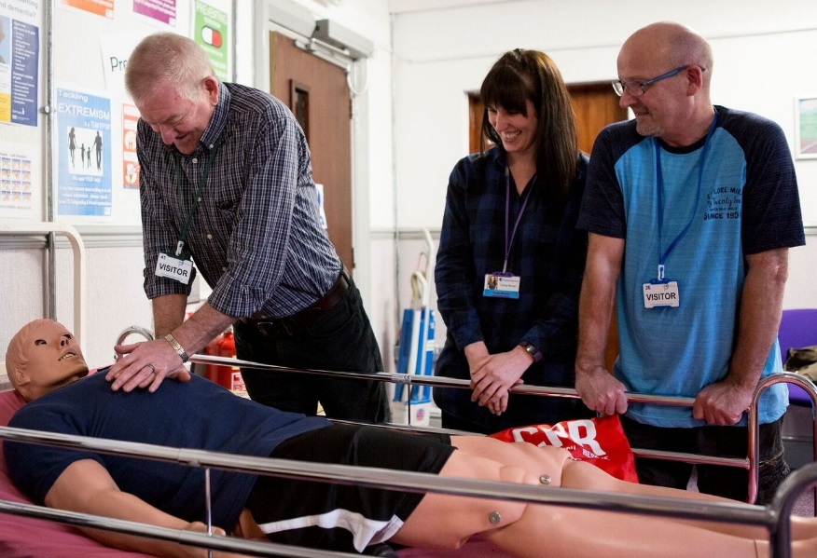

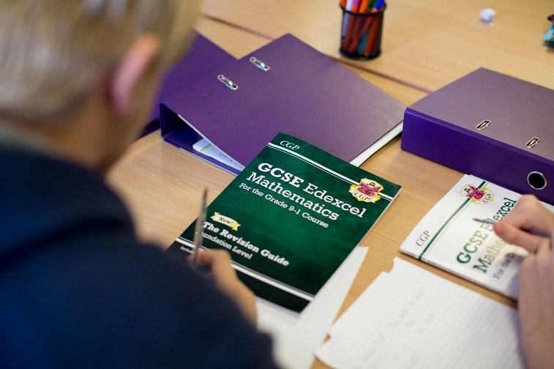

Contents

- Welcome letter from Chief Executive Officer
- Company Structure
- Job Profile
- Terms and Conditions
- Recruitment Timetable
- How to Apply

Letter from the CEO

Dear Applicant,

Thank you for your interest in our organisation, and in the role of Functional Skills/Employability Tutor.

ITS Group has been established since 1981 and is a leading education and training charity, with a passion to deliver our promise.

We operate as a whole organisation, with three key business units;

- ITS College Classroom based vocational and academic education
- ITS Apprenticeship & Training Work-based vocational training
- ITS SmartStyle Training Business to business training

Our 2020 Business Plan sets out our ambitious strategy to grow and maximise the opportunities created by a dynamic market. As we shape ITS Group to take the lead at this exciting time we look to strengthen our Study Programme unit with this key role Functional Skills/Employability Tutor to help deliver our overall goals.

If you are this person, we look forward to hearing from you.

Thank you

Chris Payne

Dr Chris Payne (FCMI)

Company Structure
Deliver the Business
Administer the Business
Generate the Business

Board of Trustees

Chris Payne – Chief Executive Officer

Administer the Business  Michelle Crossley – Corporate Services Director | Deliver the Business  Jane Vaughan – Chief Operating Officer | Generate the Business  Peter Lawrence – Commercial Director

JOB PROFILE – Functional Skills & Employability Skill Tutor

JOB PURPOSE & KEY ACCOUNTABILITIES

To provide an effective and high quality delivery programme that meets the individual needs and aspirations of learners towards successful outcomes.
PORTFOLIO

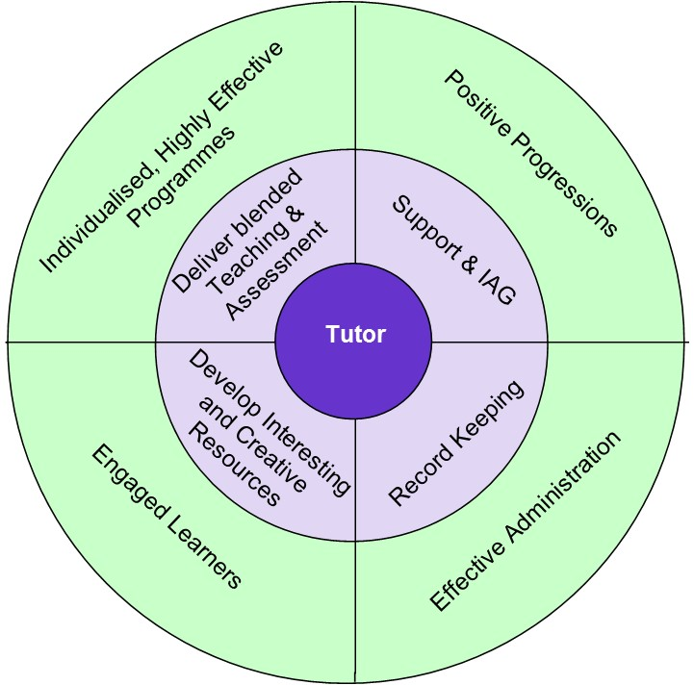

RELATIONSHIPS
Directly reporting to: Study Programme Manager
Responsible for: No direct reports
Functional relationship: Working with all other Delivery Teams and Managers to ensure provision is coordinated effectively into relevant programmes. Work with appropriate external agencies and organisations to support referrals, signposting and progression opportunities.

KEY RESPONSIBILITIES

- Deliver blended Teaching and Assessment
Deliver highly effective blended teaching, learning and assessment for learners

- Support & IAG
Provide appropriate information, advice and guidance that supports learner progression to a positive destination, including onto Apprenticeships with ITS Group.

- Develop Interesting and Creative Resources
Develop resources that are interesting and creative to support learner progress and retain learner engagement

- Record Keeping
Complete and update documentation to a high level of accuracy and detail

CAPABILITIES
BUSINESS CONTRIBUTION
- You understand where you fit in the organisation’s success and hold yourself to account
- You contribute to setting your own achievable objectives in line with the business plan
- You take personal responsibility for making the right things happen which add value

CUSTOMER FOCUS
- You ensure that every action/decision takes into consideration the impact on the customer
- You understand who all our customers are and respond appropriately

WORKING WITH OTHERS
- You work collaboratively and independently as situations require for a successful organisational outcome
- You are proactive in providing appropriate support and guidance to others to achieve organisational results

PERSONAL DEVELOPMENT
- You actively develop yourself in line with business needs
- You show good awareness of your own values, motivations and emotions
- You prioritise objectives and plan work to make best use of own and others time and resources
- You actively seek, analyse and build on feedback to improve performance

CONTINUOUS IMPROVEMENT
- You establish and use effective methods to review and improve activities
- You make appropriate decisions which balance implications, consequence, risk and required outcomes
- You actively seek and act on opportunities to improve

PERSON SPECIFICATION
KEY:
The following key shows at which stage of the selection process the criteria needs to be evidenced.
(A) Application form
(I) Interview
(P) Performance of Assessment
(D) Documentary Evidence
(L) Lesson Observation

ATTRIBUTES | ESSENTIAL | DESIRABLE
Qualifications | (A) GCSEs or Level 2 in both English and Maths  (A) Teaching Qualification (PTTLLS, CertED, PGCE) | (D) Assessor qualification/ IQA qualification
Experience | (A, I, L) Experience of teaching Functional Skills English and maths to Level 2  (A, I) Experience of Functional Skills maths and English qualifications  (A, L) Classroom teaching experience  (A, L) Experience of developing teaching material | (A, I) Experience of working with 16- 24 year olds and young adults  (A, I) Experience of teaching GCSE maths and/or English.  (A, I, L) Experience of working with individuals with challenging behaviour.
Knowledge / Skills | (A, I, L) Knowledge and understanding of complex learning needs  (A, I, L) Knowledge of classroom management principles and ability to apply these. | (I) Knowledge and understanding of the Common Inspection Framework  (L) Knowledge GCSE maths and English qualifications  (I) Knowledge and understanding of SEN and support mechanisms/ techniques
Personal Attributes | (A, I) Ability to achieve results  (I, L) Excellent communication skills – both written and verbal  (A, I, L) Strong organisational skills.  (A) A commitment to the Capabilities – ITS Employee | (I) To be able to work flexibly in order to meet the needs of the service when required.

Recruitment Timetable

Thursday 28th February 2019 | Closing date for applications
Friday 1st March 2019 | Short-listing notification (via email/phone)
Friday 8th March 2019 | Interview day
Monday 11th March 2019 | Final outcome notification

Terms, Conditions and Benefits

- Salary – £17,500 - £24,000 depending on experience
- Pension Scheme – The appointed individual will be entitled to join the company pension scheme
- Holidays – 32 days per annum (FTE) – Plus all public and bank holidays
- Westfield Healthcare Scheme
- Travel Expenses

How to Apply

If you are interested in applying for this role, please email hr@ind-training.co.uk or contact Alison Hardwick/Sam Hanson on 01226 295471 to request an Application Pack (Application Form and Equal Opportunities Monitoring Form) or visit our website: www.ind-training.co.uk

Please ensure you provide the following:

- A fully completed Application Form which includes two referees, one of whom should be your current or most recent employer, let us know whether you would be happy for us to contact them as part of the process. Referees will not, of course, be contacted without your prior consent.

- A supporting statement. This should clearly set out how you meet each of the criteria set out in the person specification contained within document. You should provide evidence in your statement; and not simply a broad claim to have done it – give us examples and dimensions; tell us what this achieved and how it helped meet your organisation’s goals.

- Equal Opportunities Monitoring Form

Please ensure that you indicate in your application any dates when you will not be available, or where we you might have difficulty in contacting you, which coincide with the recruitment timetable.

All applications will be acknowledged.

ITS Group will respect the privacy of any initial approach or expression of interest in this role, whether formal or informal.

Closing date for applications: 28th February 2019

