___________________________________________________________

JOB PROFILE – Training Manager (Hospitality)

___________________________________________________________

JOB PURPOSE & KEY ACCOUNTABILITIES

To deliver teaching, learning and assessment and maintain a portfolio of employers and learners to high quality standards.

PORTFOLIO
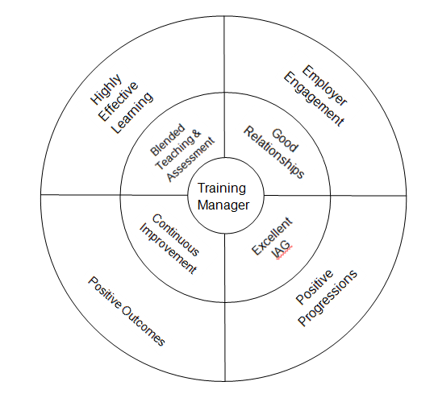

RELATIONSHIPS
Directly reporting to: Business Manager
Responsible for: No direct reports
Functional relationship: Working with all other Delivery Teams and Managers to ensure vocational provision is coordinated effectively into all programmes. Working with all business units within ITS Group to ensure high quality outcomes are gained. Building relationships with learners and employers as well as other relevant external parties who may be involved with the provision.

KEY RESPONSIBILITIES
- Blended Teaching & Assessment: To deliver highly effective teaching, learning and assessment for learners in the Hospitality sector, plus English and Maths Functional Skills, using blended learning approaches.
- Good Relationships: To maintain own optimum caseload value by building relationships with new and existing employers and identifying potential new learners.
- Excellent IAG: To carry out and use initial assessment of potential learners, and ensure that additional support needs are met and to provide quality information, advice and guidance to learners and therefore enhance career progression opportunities.
- Continuous Development: To provide a contribution to the development of the sector’s continuous improvement within the business, developing and designing course material, sharing best practice and looking for innovation in teaching delivery.

CAPABILITIES
BUSINESS CONTRIBUTION
- You understand where you fit in the organisation’s success and hold yourself to account
- You contribute to setting your own achievable objectives in line with the business plan
- You take personal responsibility for making the right things happen which add value

CUSTOMER FOCUS
- You ensure that every action/decision takes into consideration the impact on the customer.
- You understand who all our customers are and respond appropriately

WORKING WITH OTHERS
- You work collaboratively and independently as situations require for a successful organisational outcome
- You are proactive in providing appropriate support and guidance to others to achieve organisational results

PERSONAL DEVELOPMENT
- You actively develop yourself in line with business needs
- You show good awareness of your own values, motivations and emotions
- You prioritise objectives and plan work to make best use of own and others time and resources
- You actively seek, analyse and build on feedback to improve performance

CONTINUOUS
- You establish and use effective methods to review and improve activities
- You make appropriate decisions which balance implications, consequence, risk and required outcomes
- You actively seek and act on opportunities to improve

PERSON SPECIFICATION

KEY:
The following key shows at which stage of the selection process the criteria needs to be evidenced.
(A) Application form
(I) Interview
(P) Performance of Assessment
(D) Documentary Evidence
(L) Lesson Observation

ATTRIBUTES | ESSENTIAL | DESIRABLE
Qualifications | (A, I, D) Teaching qualification  (A, I, D) Assessor qualification  (A, I,D) Qualified to deliver Hospitality Qualification up to level 3 | (A, I, D) IV qualification  (D) Qualified to deliver Food Safety qualifications
Experience | (A, I, L) Experience of delivering hospitality and catering qualifications  (A, I) Experience of working in the hospitality (back of house) industry  (A, I) Experience of developing teaching material | (A, I) Experience of teaching First Aid and/or Health & Safety qualifications  (A, I) Experience of working in the hospitality (front of house) industry
Knowledge / Skills | (A, I) Knowledge and understanding of Common Inspection Framework  (A, I, P) Understanding of different learning needs | (A, I) Experience of Ofsted inspection  (A, I) Knowledge and application of e-learning  (A, I) Experience of using e-Portfolio (in particular OneFile)
Personal Attributes | (A, I) Ability to achieve results  (A, I) Ability to work on own initiative and self-manage  (A, I) Commitment to continuous improvement  (A, I, L) Ability to empathise with the difficulties of learners and barriers to learning  (A, I) Commitment to the Capabilities – ITS Employee
Additional requirements | (D) Driving licence and use of a car  (I) Ability to work flexibly

