Appointment Brief

Business Manager
(Leadership & Management)

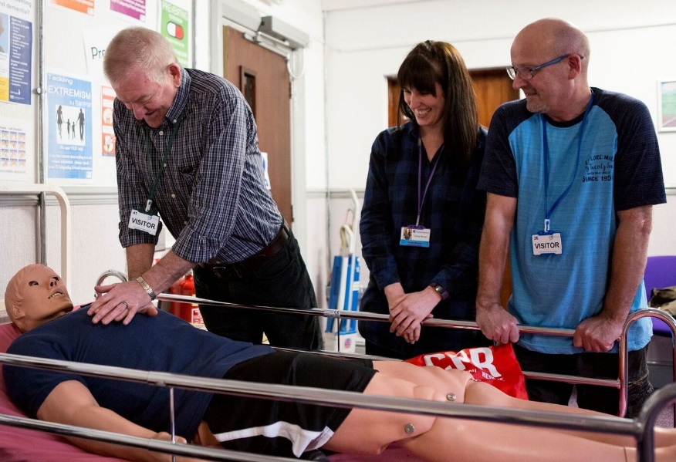

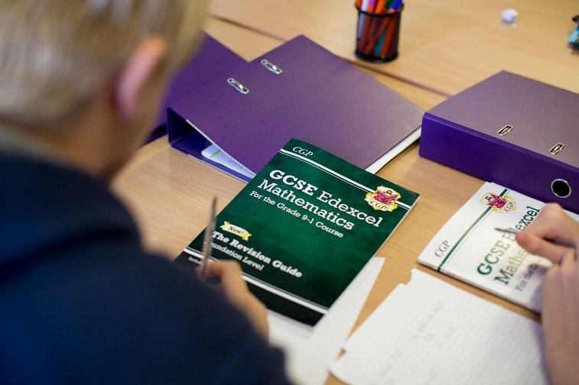

Contents

- Welcome letter from Chief Executive Officer
- Company Structure
- Job Profile
- Terms and Conditions
- Recruitment Timetable
- How to Apply

Letter from the CEO

Dear Applicant,

Thank you for your interest in our organisation, and in the role of Business Manager.

ITS Group has been established since 1981 and is a leading education and training charity, with a passion to deliver our promise.

We operate as a whole organisation, with three key business units;

- ITS College Classroom based vocational and academic education
- ITS Apprenticeship & Training Work-based vocational training
- ITS SmartStyle Training Business to business training

Our 2020 Business Plan sets out our ambitious strategy to grow and maximise the opportunities created by a dynamic market. As we shape ITS Group to take the lead at this exciting time we look to strengthen our Delivery business unit with this key role ‘Business Manager (Leadership & Management)’ to help deliver our overall goals.

You may come from any Management discipline, as long as you truly embody our values and will bring commercial acumen, self-drive and flair to help us develop, deliver and grow our high quality Leadership and Management provision.

If you are this person, we look forward to hearing from you.

Thank you

Chris Payne

Dr Chris Payne (FCMI)

Company Structure

Board of Trustees

Chris Payne – Chief Executive Officer

Administer the Business  Michelle Crossley – Corporate Services Director | Deliver the Business  Jane Vaughan – Chief Operating Officer | Generate the Business  Peter Lawrence – Commercial Director

JOB PROFILE – Business Manager for Leadership & Management

JOB PURPOSE & KEY ACCOUNTABILITIES
Business Manager [Designate] for Leadership and Management
Design, develop and manage the ITS Group’s Leadership and Management Business Unit

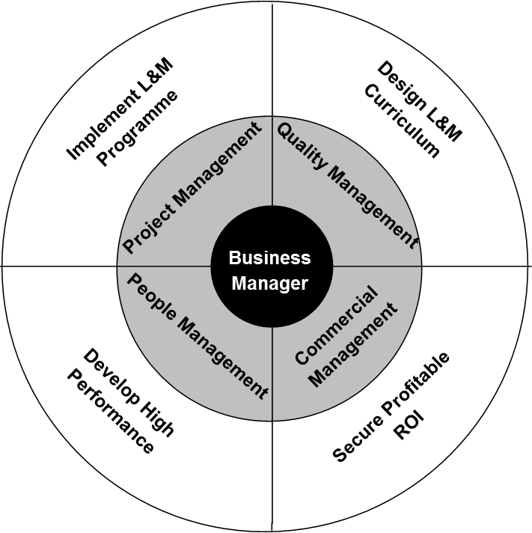

RELATIONSHIPS
Directly reporting to: TBC
Responsible for: TBC
Functional relationship Working closely alongside all business units across ITS Group.

KEY RESPONSIBILITIES
- Project
To formulate and implement an effective (high quality) Leadership & Management Programme

- Quality
To design and construct a L&M curriculum

- Commercial
To secure profitable income from existing/new business and existing/new markets

- People
To develop and lead a high performing business unit

CAPABILITIES
BUSINESS CONTRIBUTION
- You understand where you fit in the organisation’s success and hold yourself to account
- You contribute to setting your own achievable objectives in line with the business plan
- You take personal responsibility for making the right things happen which add value

CUSTOMER FOCUS
- You ensure that every action/decision takes into consideration the impact on the customer
- You understand who all our customers are and respond appropriately

WORKING WITH OTHERS
- You work collaboratively and independently as situations require for a successful organisational outcome
- You are proactive in providing appropriate support and guidance to others to achieve organisational results

PERSONAL DEVELOPMENT
- You actively develop yourself in line with business needs
- You show good awareness of your own values, motivations and emotions
- You prioritise objectives and plan work to make best use of own and others time and resources
- You actively seek, analyse and build on feedback to improve performance

CONTINUOUS IMPROVEMENT
- You establish and use effective methods to review and improve activities
- You make appropriate decisions which balance implications, consequence, risk and required outcomes
- You actively seek and act on opportunities to improve

PERSON SPECIFICATION
KEY:
The following key shows at which stage of the selection process the criteria needs to be evidenced.
(A) Application form
(I) Interview
(P) Performance of Assessment
(D) Documentary Evidence

ATTRIBUTES | ESSENTIAL | DESIRABLE
Qualifications | (A,I,D) Level 5 Management qualification | (A,I,D) Teaching qualification  (A,I,D) Assessor and IQA Award or equivalent  (A,I,D) Degree Management qualification
Experience | (A, I, P) Experience of delivering teaching, learning and assessment in Leadership and Management  (A, I) Experience of managing a team  (A, I, P) Experience of designing Leadership and Management programmes  (A, I) Ability to lead a team to achieve results | (A, I) Experience of Ofsted inspection  (A, I) Experience of commercial courses
Knowledge | (A, I) Knowledge of current local, regional and national labour market intelligence  (A, I) Knowledge and understanding of the Common Inspection Framework  (A, I) Knowledge of Leadership and Management qualifications and short courses | (A, I) Knowledge of SFA and EFA funding rules and contracts  (A, I) Knowledge and application of ELearning and delivering teaching through VLE  (A, I) Knowledge and understanding of e-Portfolio, particularly One File
Skills and Attributes | (A, I) Ability to use own initiative, be self-driven and motivated  (A, I) Ability to work within a target driven environment  (A, I) A commitment to the Capabilities – ITS Employee  (A, I) Ability to contribute to a whole organisation team approach to reach ITS vision  (A, I) Ability to achieve KPI’s and meet required deadlines
Additional Requirements | (I) Willing to travel throughout the UK | (I) Car user and access to a car

Recruitment Timetable

Monday 1st April (Noon) | Closing date for applications
Tuesday 2nd April | Short-listing notification (via email/Phone)
Thursday 11th April | Interview day
Friday 12th April | Final outcome notification

Terms, Conditions and Benefits

- Salary – £30,000 - £34,000
- Pension Scheme – The appointed individual will be entitled to join the company pension scheme
- Holidays – 32 days per annum (FTE) – Plus all public and bank holidays
- Westfield Healthcare Scheme
- Travel Expenses

How to Apply

If you are interested in applying for this role, please email hr@ind-training.co.uk or contact Alison Hardwick/Sam Hanson on 01226 295471 to request an Application Pack (Application Form and Equal Opportunities Monitoring Form) or visit our website: www.ind-training.co.uk

Please ensure you provide the following:

- A fully completed Application Form which includes two referees, one of whom should be your current or most recent employer, let us know whether you would be happy for us to contact them as part of the process. Referees will not, of course, be contacted without your prior consent.

- A supporting statement. This should clearly set out how you meet each of the criteria set out in the person specification contained within this document. You should provide evidence in your statement; and not simply a broad claim to have done it – give us examples and dimensions; tell us what this achieved and how it helped meet your organisation’s goals.

- Equal Opportunities Monitoring Form

Please ensure that you indicate in your application any dates when you will not be available, or where we you might have difficulty in contacting you, which coincide with the recruitment timetable.

All application will be acknowledged.

ITS Group will respect the privacy of any initial approach or expression of interest in this role, whether formal or informal.

Closing date for applications: 1st April 2019

