Appointment Brief
Training Manager (Management)

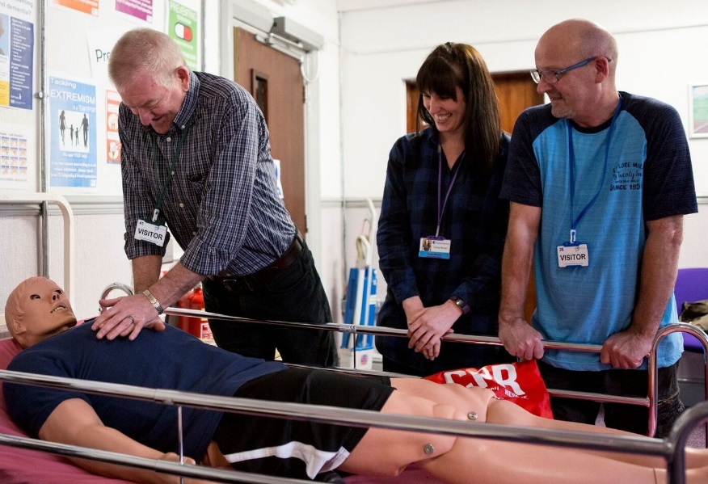

Contents

- Welcome letter from Chief Executive Officer
- Company Structure
- Job Profile
- Terms and Conditions
- Recruitment Timetable
- How to Apply

Letter from the CEO

Dear Applicant,

Thank you for your interest in our organisation, and in the role of Training Manager (Management)

ITS Group has been established since 1981 and is a leading education and training charity, with a passion to deliver our promise.

We operate as a whole organisation, with three key business units;

- ITS College Classroom based vocational and academic education
- ITS Apprenticeship & Training Work-based vocational training
- ITS SmartStyle Training Business to business training

Our 2020 Business Plan sets out our ambitious strategy to grow and maximise the opportunities created by a dynamic market. As we shape ITS Group to take the lead at this exciting time we look to strengthen our Professional Services Business Unit with this key role ‘Training Manager - Management’ to help deliver our overall goals.

Applicants should truly embody our values and will bring with them self-drive and flair to help us grow and deliver high quality education and training.

If you are this person, we look forward to hearing from you.

Thank you

Chris Payne

Dr Chris Payne (FCMI)

Company Structure

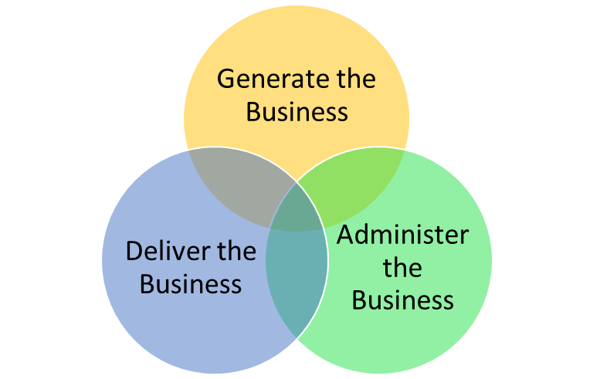

Board of Trustees

Chris Payne – Chief Executive Officer

Administer the Business  Michelle Crossley – Corporate Services | Deliver the Business  Jane Vaughan – Chief Operating Officer | Generate the Business  Peter Lawrence – Commercial Director

JOB PROFILE – Training Manager (Management)

JOB PURPOSE & KEY ACCOUNTABILITIES

To deliver teaching, learning and assessment and maintain a portfolio of employers and learners to high quality standards.

PORTFOLIO
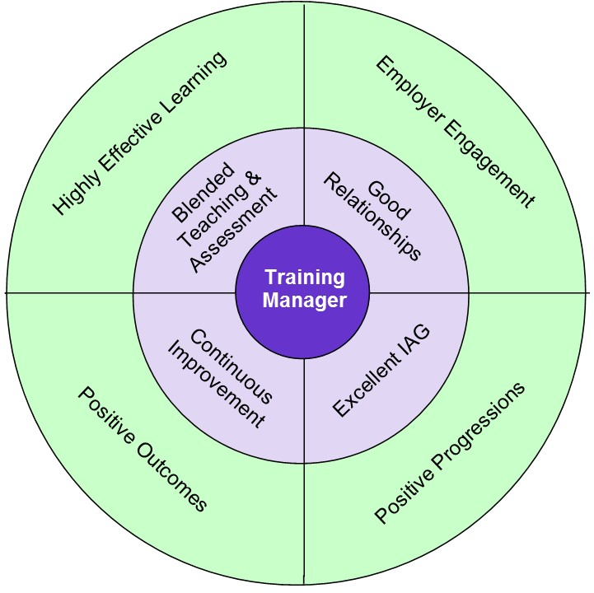

RELATIONSHIPS
Directly reporting to: Business Manager
Responsible for: No direct reports
Functional relationship: Working with all other Delivery Teams and Managers to ensure the provision is coordinated effectively into all programmes. Working with all business units within ITS Group to ensure high quality outcomes are gained. Building relationships with learners and employers as well as other relevant external parties who may be involved with the provision.

KEY RESPONSIBILITIES
- Blended Teaching & Assessment - To deliver highly effective teaching, learning and assessment for learners in the Management sector including blended learning approaches.
- Good Relationships - To maintain own optimum caseload value by building relationships with new and existing employers and identifying potential new learners.
- Excellent IAG - To carry out initial assessment of potential learners and use the results to ensure that additional support needs are met. To provide quality information, advice and guidance to learners and therefore enhance career progression opportunities.
- Continuous Development - To provide a contribution to the development of the sector within the business, developing and designing course material, sharing best practice and looking for innovation in teaching delivery.

CAPABILITIES
BUSINESS CONTRIBUTION
- You understand where you fit in the organisation’s success and hold yourself to account
- You contribute to setting your own achievable objectives in line with the business plan
- You take personal responsibility for making the right things happen which add value

CUSTOMER FOCUS
- You ensure that every action/decision takes into consideration the impact on the customer
- You understand who all our customers are and respond appropriately

WORKING WITH OTHERS
- You work collaboratively and independently as situations require for a successful organisational outcome
- You are proactive in providing appropriate support and guidance to others to achieve organisational results

PERSONAL DEVELOPMENT
- You actively develop yourself in line with business needs
- You show good awareness of your own values, motivations and emotions
- You prioritise objectives and plan work to make best use of own and others time and resources
- You actively seek, analyse and build on feedback to improve performance

CONTINUOUS IMPROVEMENT
- You establish and use effective methods to review and improve activities
- You make appropriate decisions which balance implications, consequence, risk and required outcomes
- You actively seek and act on opportunities to improve

PERSON SPECIFICATION
KEY:
The following key shows at which stage of the selection process the criteria needs to be evidenced.
(A) Application form
(I) Interview
(P) Performance of Assessment
(D) Documentary Evidence
(L) Lesson Observation

ATTRIBUTES | ESSENTIAL | DESIRABLE
Qualifications | (A,I,D) Teaching qualification  (A,I,D) Assessor qualification | (A,I,D) IQA qualification
Experience | (A,I,L) Experience of delivering Management  (A,I,L) Experience of developing teaching material | (A,I,L) Experience of delivering Business Administration and ICT  (A, I) Experience of teaching First Aid and/or Health & Safety qualifications
Knowledge / Skills | (A, I) Knowledge and understanding of Common Inspection Framework  (A,I,L) Understanding of different learning needs | (A, I) Experience of Ofsted inspection  (A, I) Knowledge and application of  e-Learning  (A, I) Experience of using e-Portfolio (in particular OneFile)
Personal Attributes | (A, I) Ability to achieve results  (A, I) Ability to work on own initiative and self-manage  (A, I) Commitment to continuous improvement  (A,I,L) Ability to empathise with the difficulties of learners and barriers to learning  (A, I) Commitment to the Capabilities – ITS Employee as stated for page 2
Additional requirements | (A,D) Driving licence and use of a car  (A,I) Ability to work flexibly & unsocial hours on a very occasional basis

Recruitment Timetable

Thursday 9th 2019 May | Closing date for applications
Friday 10th 2019 May | Short-listing notification (via email/Phone)
Friday 17th May 2019 | Interview Date
Friday 17th May 2019 | Final Outcome Notification

Terms, Conditions and Benefits

- Salary – c. £26,000 - £30,000 pa, plus benefits
- Pension Scheme – The appointed individual will be entitled to join the company pension scheme
- Holidays – 32 days per annum (FTE) – Plus all public and bank holidays
- Westfield Healthcare Scheme
- Travel Expenses

How to Apply

If you are interested in applying for this role, please email hr@ind-training.co.uk or contact Alison Hardwick/Sam Hanson on 01226 295471 to request an Application Pack (Application Form and Equal Opportunities Monitoring Form) or visit our website: www.ind-training.co.uk

Please ensure you provide the following:

- A fully completed Application Form which includes two referees, one of whom should be your current or most recent employer, let us know whether you would be happy for us to contact them as part of the process. Referees will not, of course, be contacted without your prior consent.

- A supporting statement. This should clearly set out how you meet each of the criteria set out in the person specification contained within this document. You should provide evidence in your statement; and not simply a broad claim to have done it – give us examples and dimensions; tell us what this achieved and how it helped meet your organisation’s goals.

- Equal Opportunities Monitoring Form

Please ensure that you indicate in your application any dates when you will not be available, or where we you might have difficulty in contacting you, which coincide with the recruitment timetable.

All application will be acknowledged.

ITS Group will respect the privacy of any initial approach or expression of interest in this role, whether formal or informal.

Closing date for applications: 09.05.19 (Noon)

