Appointment Brief

Training Director
(Leadership & Management)

Contents

- Welcome letter from Chief Executive Officer
- Company Structure
- Job Profile
- Terms and Conditions
- Recruitment Timetable
- How to Apply

Letter from the CEO

Dear Applicant,

Thank you for your interest in our organisation, and in the role of Training Director (Leadership & Management).

ITS Ltd has been established since 1981 and is a leading education and training charity, with a passion to deliver our promise.

We operate as a whole organisation, with two key business units;

- ITS Apprenticeship & Training Work-based vocational training
- ITS SmartStyle Training Business to business training

Our 2020 Business Plan sets out our ambitious strategy to grow and maximise the opportunities created by a dynamic market. As we shape ITS Ltd to take the lead at this exciting time we look to strengthen our Delivery business unit with this key role ‘Training Director (Leadership & Management)’ to help deliver our overall goals.

You may come from any Management discipline, as long as you truly embody our values and will bring commercial acumen, self-drive and flair to help us develop, deliver and grow our high quality Leadership and Management provision.

If you are this person, we look forward to hearing from you.

Thank you

Chris Payne

Dr Chris Payne (FCMI)

Company Structure

Board of Trustees

Chris Payne – Chief Executive Officer

Administer the Business  Michelle Crossley – Corporate Services Director | Deliver the Business  Jane Vaughan – Chief Operating Officer | Generate the Business  Peter Lawrence – Commercial Director

JOB PROFILE – Training Director for Leadership & Management

JOB PURPOSE & KEY ACCOUNTABILITIES
Training Director [Designate] for Leadership and Management
Design, develop and manage the ITS Ltd.’s Leadership and Management Business Unit
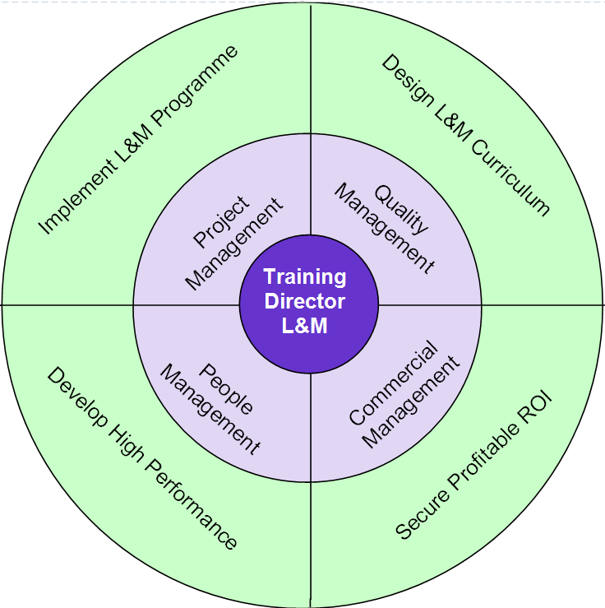
RELATIONSHIPS
Directly reporting to: Commercial Director
Responsible for: Leadership & Management Business Unit
Functional relationship Working closely alongside all business units across ITS Ltd.

KEY RESPONSIBILITIES
- Project
  - To research, formulate, develop and implement an effective (high quality) Leadership & Management Programme.
  - Lead on strategic development of Leadership and Management provision to meet local, regional and national priorities.

- Quality
  - To design and construct a Leadership and Management curriculum with inspires learners and promotes enjoyment of learning whilst meeting employer workforce solutions.
  - To take overall responsibility for all aspects of high quality teaching, learning and assessment within the Leadership and Management business unit.

- Commercial
  - To secure profitable income from existing/new business and existing/new markets.
  - Represent ITS Group positively and highly effectively in all dealings with external partners, parents, stakeholders and agencies.
  - Develop networks and relationships with key stakeholders including employers.

- People
  - To develop and lead a high performing business unit.
  - Ensure that individual staff and teams are supported to maximise their effectiveness through continuing professional development

CAPABILITIES
BUSINESS CONTRIBUTION
- You understand where you fit in the organisation’s success and hold yourself to account
- You contribute to setting your own achievable objectives in line with the business plan
- You take personal responsibility for making the right things happen which add value

CUSTOMER FOCUS
- You ensure that every action/decision takes into consideration the impact on the customer
- You understand who all our customers are and respond appropriately

WORKING WITH OTHERS
- You work collaboratively and independently as situations require for a successful organisational outcome
- You are proactive in providing appropriate support and guidance to others to achieve organisational results

PERSONAL DEVELOPMENT
- You actively develop yourself in line with business needs
- You show good awareness of your own values, motivations and emotions
- You prioritise objectives and plan work to make best use of own and others time and resources
- You actively seek, analyse and build on feedback to improve performance

CONTINUOUS IMPROVEMENT
- You establish and use effective methods to review and improve activities
- You make appropriate decisions which balance implications, consequence, risk and required outcomes
- You actively seek and act on opportunities to improve

PERSON SPECIFICATION
KEY:
The following key shows at which stage of the selection process the criteria needs to be evidenced.
(A) Application form
(I) Interview
(P) Performance of Assessment
(D) Documentary Evidence

ATTRIBUTES | ESSENTIAL | DESIRABLE
Qualifications | (A,I,D) Level 5 Management qualification  (A,I,D) Teaching qualification | (A,I,D) Assessor and IQA Award or equivalent  (A,I,D) Degree or higher Management qualification
Experience | (A, I, P) Experience of delivering teaching, learning and assessment in Leadership and Management  A, I) Experience of highly effective curriculum development  (A, I) Successful leadership experience to achieve results  (A, I, P) Experience of designing Leadership and Management programmes  (A, I) Successful experience of quality improvement activities and procedures  (A, I) Strong and extensive experience of developing partnerships with external stakeholders  (A, I) Proven track record of using data to manage performance and bring about improvement | (A, I) Experience of Ofsted inspection  (A, I) Experience of commercial courses
Knowledge | (A, I) Knowledge of current local, regional and national labour market intelligence  (A, I) Knowledge and understanding of the Common Inspection Framework  (A, I) Knowledge of Leadership and Management qualifications and short courses | (A, I) Knowledge of ESFA funding rules and contracts  (A, I) Knowledge and application of ELearning and delivering teaching through VLE  (A, I) Knowledge and understanding of e-Portfolio, particularly One File
Skills and Attributes | (A, I) Ability to use own initiative, be self-driven and motivated  (A, I) Ability to work within a target driven environment  (A, I) A commitment to the Capabilities – ITS Employee  (A,I,D) High standard of literacy, numeracy and IT skills  (A, I) Ability to contribute to a whole organisation team approach to reach ITS vision  (A, I) Ability to achieve KPI’s and meet required deadlines  (A, I) Proven ability to develop positive working relationships with individuals at all levels (internal and external)  (A, I) Highly developed communication skills (written and verbal), external liaison and networking skills  (A, I) Very strong organisational and time management skills  (A, I) Demonstrate a positive approach to equality, diversity and inclusion.  (A, I) Demonstrate a commitment to safeguarding and promoting learner welfare.  (A, I) Demonstrate an ability to take responsibility for own Health and Safety at work.  (A, I) Capacity and resilience to deal with challenging performance management issues. | (A, I) Successful financial and budget management
Additional Requirements | (I) Willing to travel throughout the UK  (I) Willing to work flexibly | (A, I) Car user and access to a car

Recruitment Timetable

Closing date for applications
Short-listing notification (via email)
Interview day
Final outcome notification

Terms, Conditions and Benefits

- Salary – £ competitive
- Pension Scheme – The appointed individual will be entitled to join the company pension scheme
- Holidays – 32 days per annum (FTE) – Plus all public and bank holidays
- Westfield Healthcare Scheme
- Travel Expenses

How to Apply

If you are interested in applying for this role, please email hr@ind-training.co.uk or contact Alison Hardwick/Sam Hanson on 01226 295471 to request an Application Pack (Application Form and Equal Opportunities Monitoring Form) or visit our website: www.ind-training.co.uk

Please ensure you provide the following:

- A fully completed Application Form which includes two referees, one of whom should be your current or most recent employer, let us know whether you would be happy for us to contact them as part of the process. Referees will not, of course, be contacted without your prior consent. Also clearly set out how you meet each of the criteria set out in the person specification contained within this document. You should provide evidence in your statement; and not simply a broad claim to have done it – give us examples and dimensions; tell us what this achieved and how it helped meet your organisation’s goals.

- Equal Opportunities Monitoring Form

Please ensure that you indicate in your application any dates when you will not be available, or where we you might have difficulty in contacting you, which coincide with the recruitment timetable.

All application will be acknowledged.

ITS Ltd will respect the privacy of any initial approach or expression of interest in this role, whether formal or informal.

