Appointment Brief
Business Development Manager

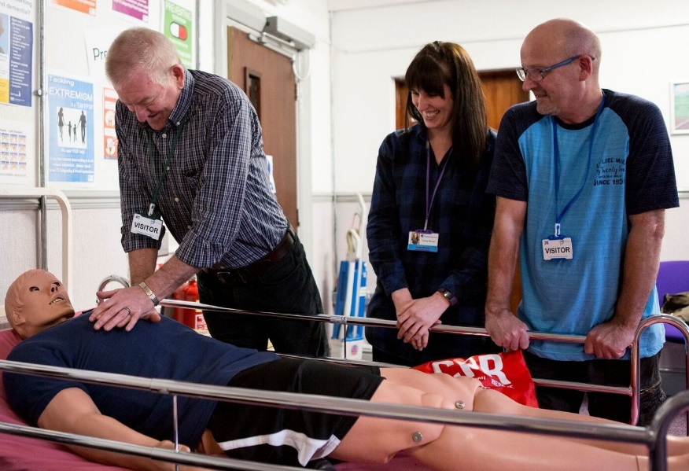

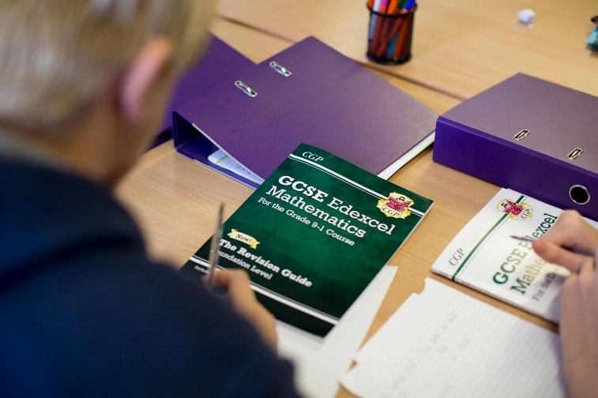

Contents

- Welcome letter from Chief Executive Officer
- Company Structure
- Job Profile
- Terms and Conditions
- Recruitment Timetable
- How to Apply

Letter from the CEO

Dear Applicant,

Thank you for your interest in our organisation, and in the role of Business Development Manager.

ITS Group has been established since 1981 and is a leading education and training charity, with a passion to deliver our promise.

We operate as a whole organisation, with three key business units;

- ITS College Classroom based vocational and academic education
- ITS Apprenticeship & Training Work-based vocational training
- ITS SmartStyle Training Business to business training

Our 2020 Business Plan sets out our ambitious strategy to grow and maximise the opportunities created by a dynamic market. As we shape ITS Group to take the lead at this exciting time we look to strengthen our Business Development unit with this key role ‘Business Development Manager’ to help deliver our overall goals.

You may come from any sales background, as long as you truly embody our values and will bring commercial acumen, self-drive and flair to help us grow and deliver high quality education and training.

If you are this person, we look forward to hearing from you.

Thank you

Chris Payne

Dr Chris Payne (FCMI)

Company Structure

Board of Trustees

Chris Payne – Chief Executive Officer

Administer the Business  Michelle Crossley – Corporate Services | Deliver the Business  Jane Vaughan – Chief Operating Officer | Generate the Business  Peter Lawrence – Commercial Director

Job Profile – Business Development Manager

JOB PURPOSE & KEY ACCOUNTABILITIES
To generate income from new prospects, existing clients, partners and new product development.

PORTFOLIO

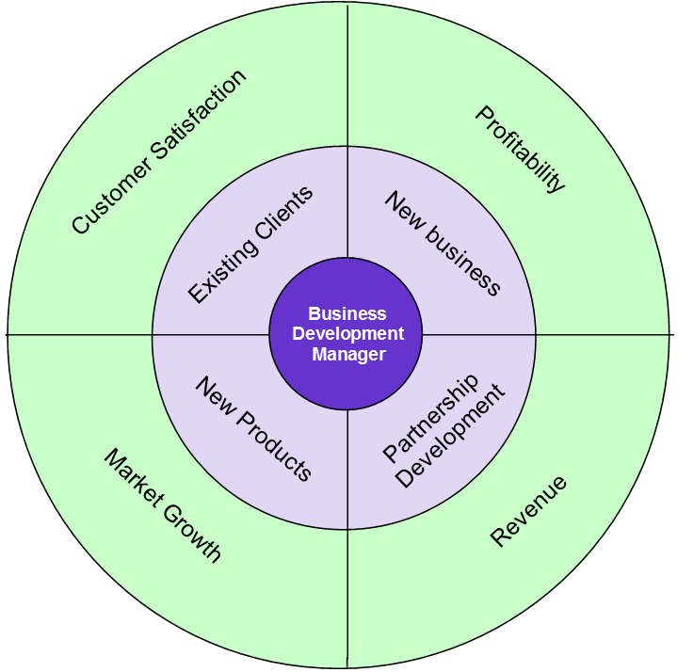

RELATIONSHIPS

Directly reporting to: Commercial Director
Responsible for: No direct reports
Functional relationship: Working closely alongside all Business Managers and with the wider ITS Group.

KEY RESPONSIBILITIES
- New Business - identify, target and engage new business opportunities, utilising effective market intelligence, and convert these to sales/clients to meet and exceed targets; contributing to the organisation’s overall profitability.

- Existing Clients - manage existing client accounts to ensure that client needs are met, strong relationships are developed and additional business opportunities are maximised; ensuring high level of customer satisfaction.

- Partnership Development - work with external agencies (partners/brokers/networking groups) to nurture and grow relationships resulting in more referrals, increased income generation and our client needs being met; form new lines of revenue.

- New Products - collaborate with colleagues in the wider ITS Group to prepare, analyse and report on current and projected positions relating to market share, lead generation, sales volumes, proposals, agreements, new product development and other employer engagement related activities, sharing sales information and best practice; contributing to Group income, profitability and market growth

CAPABILITIES
BUSINESS CONTRIBUTION
- You understand where you fit in the organisation’s success and hold yourself to account
- You contribute to setting your own achievable objectives in line with the business plan
- You take personal responsibility for making the right things happen which add value

CUSTOMER FOCUS
- You ensure that every action/decision takes into consideration the impact on the customer
- You understand who all our customers are and respond appropriately

WORKING WITH OTHERS
- You work collaboratively and independently as situations require for a successful organisational outcome
- You are proactive in providing appropriate support and guidance to others to achieve organisational results

PERSONAL DEVELOPMENT
- You actively develop yourself in line with business needs
- You show good awareness of your own values, motivations and emotions
- You prioritise objectives and plan work to make best use of own and others time and resources
- You actively seek, analyse and build on feedback to improve performance

CONTINUOUS IMPROVEMENT
- You establish and use effective methods to review and improve activities
- You make appropriate decisions which balance implications, consequence, risk and required outcomes
- You actively seek and act on opportunities to improve

PERSON SPECIFICATION
KEY:
The following key shows at which stage of the selection process the criteria needs to be evidenced.
(A) Application form
(I) Interview
(P) Performance of Assessment
(D) Documentary Evidence

ATTRIBUTES | ESSENTIAL | DESIRABLE
Qualifications | (A,I,D) Level 2 English & maths | (A,I,D) Level 3 in Sales, Business Studies, Customer Care
Experience | (A, I) At least 2 years B2B sales experience  (A, I) Track record of income generation  (A, I) Experience of working toward KPIs & exceeding targets | (A, I) Background in training, human resources or learning & development  (A, I) Marketing experience
Knowledge/Skills | (A,I,P)Telemarketing & face-to-face solution selling  (A, I) Able to manage & prioritise own workload  (A,I,P) Ability to analyse statistical information & produce related reports  (A,I,P) Proficient with ICT / Microsoft Office applications | (A, I) Experience of effectively using a CRM  (A, I) Knowledge of ONA & workforce development solutions
Personal Attributes | (A,I) Confident, comfortable and capable in a sales environment  (A, I) Exceptional communication skills in all forms (written, face to face & over the telephone)  (A, I) Able to use own initiative, be self-driven & motivated  (A, I) Able to generate rapport with people at all levels  (A, I) A commitment to work towards the ITS Capabilities  (A, I) Team oriented
Additional requirements | (D) Driving licence, use of a car & willingness to travel throughout the UK  (A, I) Ability to work flexibly & unsocial hours on a very occasional basis

Recruitment Timetable

TBC | Closing date for applications
 | Short-listing notification (via email/Phone)
 | Interview day
 | Final outcome notification
 | Potential Start Date

Terms, Conditions and Benefits

- Salary – £25k + Performance Related Pay and Benefits
- Pension Scheme – The appointed individual will be entitled to join the company pension scheme
- Holidays – 32 days per annum (FTE) – Plus all public and bank holidays
- Westfield Healthcare Scheme
- Travel Expenses

How to Apply

If you are interested in applying for this role, please email hr@ind-training.co.uk or contact Alison Hardwick/Sam Hanson on 01226 295471 to request an Application Pack (Application Form and Equal Opportunities Monitoring Form) or visit our website: www.ind-training.co.uk

Please ensure you provide the following:

- A fully completed Application Form which includes two referees, one of whom should be your current or most recent employer, let us know whether you would be happy for us to contact them as part of the process. Referees will not, of course, be contacted without your prior consent. Also clearly set out how you meet each of the criteria set out in the person specification contained within this document. You should provide evidence in your statement; and not simply a broad claim to have done it – give us examples and dimensions; tell us what this achieved and how it helped meet your organisation’s goals.

- Equal Opportunities Monitoring Form

Please ensure that you indicate in your application any dates when you will not be available, or where we you might have difficulty in contacting you, which coincide with the recruitment timetable.

All application will be acknowledged.

ITS Group will respect the privacy of any initial approach or expression of interest in this role, whether formal or informal.

